**1.INTRODUCTION**

* 1. **Project Overview**

My project is about an exhibition and named as **“*Expo Management”*** and t is a web based application. Expo Management it means a system to manage the details of Tickets, Company, Bookings, Expo, Ticket Prices . It manages the information about Tickets, Customers, Ticket Prices, Tickets .

The project is totally built at administrative end and thus only the administrator is guaranteed the access .The purpose of the project is to build an application program to reduce the manual work for managing the Tickets, Company, Customers, Bookings.

With the increasing growth in the number of industries and the competitive run for the trophy of perfection and profit, these industries round the globe are in the lookout for a roof to exhibit their products in the most convenient, profitable and successful means. Chambers of Commerce and Industrial Associates around the world conduct expos or large trade fairs and exhibitions with the aim of promoting their products and companies. The organizers face a huge amount of effort in conduction such large scale expos. Nevertheless organizing such exhibitions not only give companies good exposure but also servers to agree upon big deals and agreements with other corporate or potential clients.

It tracks all the details about the Bookings, Expo, Ticket Prices. In a shop we can get a product with same type is two or more. But in this way we can order a bulk of product with same type. Example we need paintings there are different type is available.

**2. SYSTEM ANALYSIS**

System analysis is the process of collecting and interpreting facts, understanding problems and using the information to suggest Improvement on the system. This will help to understand the existing system and determine how computers make its operation more effective. The aim of this analysis is to collect detailed information on the system and the feasibility study of the proposed system.

**2.1. Existing system**

Coming to this existing system ordering and purchasing is done by manual process. In this existing system user get products from the shop and there is only limited no of products. So we cannot get maximum no of products. In this way we cannot purchase bulk of products. More quantity is not available. And also we buy a thing from the shop the user can only the contact with the shop there is no contact with the company .

So, the existing system is carries more time to order and purchase and also no contact between the company and we cannot give any suggestion to it for thisreason the online system is implemented.

**2.1.1. Problem with Existing System**

* Increase amount of time to purchase
* Large amount Payment is not possible by manually
* There is no contact between the company
* Cannot express the details about the product quality and not give any suggestions
* Cannot access from anywhere
* Bulk of products is not available
* Cannot get various types.

**2.2.Proposed System**

Here we aimed to design online web application for an exhibition or expo. With the increasing growth in the number of industries and the competitive run for the trophy of perfection and profit, these industries round the globe are in the lookout for a roof to exhibit their products in the most convenient, profitable and successful means. Chambers of Commerce and Industrial Associates around the world conduct expos or large trade fairs and exhibitions with the aim of promoting their products and companies. The organizers face a huge amount of effort in conduction such large scale expos. Nevertheless organizing such exhibitions not only give companies good exposure but also servers to agree upon big deals and agreements with other corporate or potential clients.

It is very useful to companies and users. In this way the user can know about the various expos and done by the companies and the products sell in the expo, also the details about the dates of the expos and the ticket details. It is also helpful to order and purchase bulk of products.

**2.2.1. Advantages of proposed system**

* Interaction between the user and company
* Decrease the time
* Transactions are easy
* Purchase and order
* It can access from anywhere
* Bulk of products are available
* Give suggestion to the company about their products
* Easy to get various products.

**2.3 Requirement collection**

There are many methods to collect and analyze requirements. They are conducting interview, sending out questionnaires, studying similar systems etc. In expo management I prefer the interview method. In this method I interviewed some people those who involved in the current system process. We can categories those people into three. They are admin, company exhibitor and user. For the interview, I asked some questions. Some of the questions and answers are given below.

**Interview with Admin**

|  |  |  |  |  |
| --- | --- | --- | --- | --- |
| **No.** |  | **Questions** |  | **Answers** |
|  |  |  |  |  |
| 1 |  | How you keep feedback reports  Of the approved  Exhibitor and expo |  | We are keeping feedback reports in a record. For keeping approved reports each exhibitor and expo have separate record. |
| 2 |  | What is the main criteria used to give the land mark for exhibitor |  | We will check the request of exhibitor and if it is perfect we will give the landmark details |
| 3 |  | How you approve expos and exhibitor |  | We will check the details of requested expos and finally we approve or reject the request |
| 4 |  | Do you feel difficulty in the existing system? If yes, what are the |  | No, I don’t think so |

|  |  |  |
| --- | --- | --- |
| **Interview with exhibitor** |  |  |

|  |  |  |  |  |
| --- | --- | --- | --- | --- |
| **No** |  | Question |  | Answer |
| 1 |  | How you add expos? |  | we create an expo account and wait for the approvals |
| 2 |  | How does the transaction process work? |  | Transaction process is done by online |
|  |  |  |  |  |
| 3 |  | Do you feel difficulty in the existing system? If yes, what are the difficulties |  | No, I don’t think so |
| 4 |  |  |  |  |
|  |  | Which medium do you prefer to input data |  | Mouse |

**Interview with company**

|  |  |  |  |  |
| --- | --- | --- | --- | --- |
| **No** |  | Question |  | Answers |
|  |  |  |  |  |
| 1 |  | Are you facing any difficulty while interacting with users and exhibitors |  | yes |
|  |  |  |  |  |
| 2 |  | If yes, what are they? |  | Main difficulty is regarding the time management. |
|  |  |  |  |  |
| 3 |  | What are the things you expecting if we computerize the current system? |  | Time management is easy. |
|  |  |  |  |  |
| 4 |  | Which medium do you prefer to input data |  | Mouse |

**Interview with user**

|  |  |  |  |  |
| --- | --- | --- | --- | --- |
| **No** |  | Question |  | Answers |
| 1 |  | Are you satisfied with this? |  | yes |
|  |  |  |  |  |
| 2 |  | if yes, what are they? |  | Because we can view the product details online and we can buy the product the way you want online or direct delivery. |
|  |  |  |  |  |
| 3 |  | Bulk ordering is available or not ?it is effective or not |  | Its available and its also effective |
| 4 |  | Which medium do you prefer |  | Mouse |

**2.4 FEASIBILITY STUDY**

Feasibility study is made to see if the project on completion will serve the purpose of the organization for the amount of work, effort and the time that spent on it. Feasibility study lets the developer foresee the future of the project and the usefulness.

Feasibility study is a test of system proposed regarding its workability, impact on the organization, ability to meet the needs and effective use resources. Thus when a new project is proposed, it normally goes through a feasibility study before it’s approved for development.

The document provide the feasibility of the project that is being designed and lists various areas that were considered very carefully during the feasibility study of this project such as technical, economical and behavioral feasibilities.

The proposed system is theoretically investigated to check the feasibility and found that they are more reliable and reliable in the cases given below. There are three aspects in the feasibility study portion of the preliminary investigation.

* **Economic Feasibility**
* **Technical Feasibility**
* **Behavioral Feasibility**

The proposed system must be evaluated from a technical point of view first, and if technical feasible their impact on the organization must be assessed. If compatible, the operational system can be devised. Then they must be tested for economic feasibility.

***2.4.1. Economic Feasibility***

The developing system must be justified by cost and benefit. Criteria to ensure that effort is concentrated on project, which will give best, return at the earliest. One of the factors which affect the development of a new system is the cost it would require. Since the system developed as part of project work, there is no manual cost to spend for the proposed system. Also all the resources are already available, it give an indication of the system is economically possible for development.

***2.4.2. Technical Feasibility***

The system must be evaluated from the technical point of view first. The assessment of this feasibility must be based on an outline design of the system

requirement in the terms of input, output, programs, procedures and staff. Having identified an outline system, the investigation must go on suggest the type of equipment, required method developing the system, of running the system once it has been designed. The project should be developed such that the necessary functions and performance are achieved within the constraints. The project is developed within latest technology.

Through the technology may become obsolete after some period of time, due to the fact that newer version of some software supports older versions, the system may still be used. So there are only minimal constraints involved with this project. The system has been developed using VB.Net, the project is technically feasible for developed.

**2.4.3. Behavioral Feasibility**

People are inherently resistant to change and computers have been known to facilitate change. The System is designed in user friendly manner and we need to provide any special training for the persons using this software. The operating system used is Windows 8, which is also user friendly. It does not have any operational barriers. So no need to provide any special training for using this application software and hence it is behaviorally feasible.

**2.5 System Specifications**

**2.5.1 Software Specifications**

The software required for the application depends on the following factors.

* The flexibility of the software
* Software contracts
* Limitation of the software

**Software**

Operating system : Windows 8.1

Front End : asp.net

Back End : SQL

**2.5.2 Hardware Specifications**

The hardware required for the application depends on the following factors.

* Determining size and capacity requirements.
* Computer evaluation and measurement.
* Financial factors.
* Maintenance and support.

**Hardware:**

Processor : Intel(R) Pentium(R) 38050 @ 1.90GHz

1.90GHz

(32 bit)

RAM : 4.00 GB

HDD : 50GB or More

Monitor : Display Panel (1366*768)

Keyboard : Standard PS/2 keyboard

Mouse : Standard Mouse 3 Buttons

Printer : Laser/Inkjet

**2.6 Identification of Actors**

An actor is someone or something that interacts with the system. An actor is he /she what uses the system. An actor exchanges information with the system. Asking certain questions as detailed below can identify the actors of the system.

We can identify the actors through a list of questionnaires.

|  |  |  |
| --- | --- | --- |
| 1 | Who will use the main functionality of the system? | Admin, Exhibitor, User, Company |
| 2 | Who will lead support from the system and do their daily tasks? | Exhibitor , company |
| 3 | Who will maintain and administrate the system? | Admin |
| 4 | With which other systems, does this system need to interact? | Database |
| 5 | Who was interest in the result produced by the system? | Admin, User , Exhibitor , Company |

The answers to these questions bring out the actors of the system us.

• **Admin**

• **User**

* **Company**
* **Exhibitor**

**2.7 Identification of Use Cases**

**2.7.1 Use Case Diagram**

In the analysis section**,** we identified the actors such as

• Admin

• Exhibitor

* User
* Company

Here we need to specify the use cases of each actor.

**Identification of use cases**

A use cases represents the functionality of an actor. It is defined as a set of actions performed by a system, which yields an observable result. An ellipse containing its name inside the ellipse or below it represents it. It is placed inside the system boundary and connected to an actor with an association. This shows how the use cases and the actor interact.

To find out the use cases, ask the following questions to each of the actors.

* Which functions does the actor require from the system? What does the actor need to do?
* Does the actor need to read, create, destroy, modify or store some kind of information in the system?
* Does the actor has to calculate something? And want to provide information for others?
* Could the actor’s daily work be simplified or made more efficient by adding new functions to the system (typically functions which are currently not automated in the system)

**Use Cases for the actor Admin**

|  |  |  |
| --- | --- | --- |
| 1 | Which functions does the Admin require from the system? What does the Admin need to do? | Admin requires the following functionalities from the system such as add companies, remove companies, approve/reject exhibitor, change password, add feedback |
| 2 | Does the Admin need to read, create, destroy, modify or store some kind of information in the system? | Yes, the admin may login to the system as add companies and exhibitors, remove companies and exhibitors, change password, approve/reject. Add landmark and product details |
| 3 | Could the Admin daily work be simplified or made more efficient by adding new functions to the system? | Yes, the system can reduce daily work |

The above queries give the following use cases for the actor Admin

* Add landmark
* Approve expo
* Approve company
* Chat with companies and exhibitors
* Add notifications
* Add category and subcategory

**Use Cases for the actor Exhibitor**

|  |  |  |
| --- | --- | --- |
| 1 | Which functions does the exhibitor require from the system? | Exhibitor require the following functionalities from the system such as add expo,transcation are done. |
| 2 | Does the exhibitor need to read, create, destroy, modify or store some kind of information in the system? | Yes, the exhibitor may login to the system add companies and user reservations |
| 3 | Could the exhibitors ‘s daily work be simplified or made more efficient by adding new functions to the system? | Yes, the system can reduce his/her daily work. |

|  |  |  |
| --- | --- | --- |
| The above queries give the following use cases for the actor Exhibitor |  |  |
| * Register and login * Add expos * Invite companies * Booth allocation * Payment with companies * Confirm ticket booking * Chat with admin * Add notifications     **Use Cases for the actor Company**   |  |  |  | | --- | --- | --- | | 1 | Which functions does the company require from the system? What does the user need to do? | Company require the following functionalities from the system such as register and login add product details ,transactions ,view expo details etc. | | 2 | Does the company need to read, create, destroy, modify or store some kind of information in the system? | company require the following functionalities from the system such as register and login, add/view user details, edit product details, chat with exhibitor | | 3 | Could the companies’s daily  work be simplified or made more efficient by adding new functions to the system? | Yes, the system can reduce the daily work | | | | |  |  |
|  | | | | | |
| The above queries give the following use cases for the actor company   * Registration and login * View expo details * View booth details and reserve for booth * Payment * View user booking and reserve the items * Add details about the products   **Use Cases for the actor user**   |  |  |  | | --- | --- | --- | | 1 | Which functions does the user require from the system? What does the user need to do? | user require the following functionalities from the system such as register and login add view product details ,transactions ,view expo details ,ticket details etc. | | 2 | Does the user need to read, create, destroy, modify or store some kind of information in the system? | user require the following functionalities system such as register and login, add/view expo details, view product details, chat with company,book tickets. | | 3 | Could the user‘s daily work be simplified or made more efficient by adding new functions to the system? | Yes, the system can reduce the daily work | | | | |  |  |

The above queries give the following use cases for the actor student

* Register and login
* View expos
* Select and book items
* View selected item,cancellation,payament
* Ticket booking and payment
* Download ticket
* Chat with exhibitor

Admin

User

Exhibitor company

**3. SYSTEM DESIGN**

**3.1 Database Design**

A data base is a collection of inter related data stored with minimum redundancy to serve many users quickly and efficiently. In database design data independence, accuracy, privacy and security are given higher priority. Database design is an integrated approach to file design. This activity deals with the design of the physical data base. All entities and attributes have been identified while creating the database. The data base design deals with the grouping of data into number of tables so as to.

* Reduce duplication of data.
* Minimize storage phase.
* Retrieve the data efficiently.

Following are some guidelines for database design:

* Design a relational schema so that it is easy to explain its meaning. Do not combine attributes from multiple entity and relationship type into a single relation.
* Design the database schema so that no insertion, deletion or modification anomalies are present in the relation.
* As far as possible, avoid placing attributes in the base relation whose values may frequently be null.
* Design relation schema so that they can be joined with equality conditions on attributes that are either primary keys or foreign keys in a way that no spurious tuples are generated.

**3.1.1 Table Design**

**Login Table**

|  |  |  |  |
| --- | --- | --- | --- |
| **Field Name** | **Data Type** | **Key** | **Description** |
| Logid | Int | Primary key | Logid of the user,exhibitor,company |
| username | varchar(50) |  | Username of the user,exhibitor,company |
| Password | varchar(50) |  | Password of the user,company,exhibitor |
| Type | varchar(50) |  | type means admin,company,exhibitor,user |
| Status | varchar(50) |  | Approve or pending |

**User Registration Table**

|  |  |  |  |
| --- | --- | --- | --- |
| **Field Name** | **Data Type** | **Key** | **Description** |
| Userid | Int | Primary key | Userid of the user |
| Logid | Int |  | Logid of the user |
| Name | varchar(50) |  | User’s name |
| Age | Int |  | User's age |
| Housename | varchar(50) |  | User’s housename |
| Country | varchar(50) |  | Country name |
| State | varchar(50) |  | State name |
| District | varchar(50) |  | District name |
| Place | varchar(50) |  | Place name |
| Mobileno | Bigint |  | User’s mobilennumber |
| Emailed | varchar(50) |  | User’s email id |

**Exhibitor Registration Table**

|  |  |  |  |
| --- | --- | --- | --- |
| **Field Name** | **Data Type** | **Key** | **Description** |
| exhibitorId | Int | Primary key | Exhibitor’s registration id |
| Logid | Int |  | Logid of the exhibitor |
| Exhibitorname | varchar(50) |  | Exhibitor’s name |
| Age | Int |  | Exhibitor’s age |
| Gender | varchar(50) |  | Exhibitor’s gender |
| Experience | varchar(50) |  | Exhibitor’s experience |
| Address | varchar(50) |  | Exhibitor’s experience |
| Country | varchar(50) |  | Country name |
| State | varchar(50) |  | State name |
| District | varchar(50) |  | District name |
| Mobilenumber | Bigint |  | Exhibitors moblenumber |
| Emailid | varchar(50) |  | Exhibitor’s emailed |
| Photo | varchar(MAX) |  | Exhibitor’s photo |

**Company Registration Table**

|  |  |  |  |
| --- | --- | --- | --- |
| **Field Name** | **Data Type** | **Key** | **Description** |
| companyId | Int | Primary key | Company registration id |
| Logid | Int |  | Login id of company |
| Companyname | varchar(50) |  | Company’s name |
| Companytype | varchar(50) |  | Company’s type |
| Companyexperience | varchar(50) |  | Company’s experience |
| Country | varchar(50) |  | Country name |
| State | varchar(50) |  | State name |
| District | varchar(50) |  | District name |
| Streetaddress | varchar(50) |  | Street address |
| Landmark | varchar(50) |  | Landmark name |

**Category Table**

|  |  |  |  |
| --- | --- | --- | --- |
| **Field Name** | **Data Type** | **Key** | **Description** |
| categoryId | Int | Primary key | Category id |
| Categoryname | varchar(50) |  | Category name |
| Subcategoryname | varchar(50) |  | Subcategory name |

**Landmark Table**

|  |  |  |  |
| --- | --- | --- | --- |
| **Field Name** | **Data Type** | **Key** | **Description** |
| Landmarked | Int | Primary key | Landmark id |
| Country | varchar(50) |  | Country name |
| State | varchar(50) |  | State name |
| District | varchar(50) |  | District name |
| Place | varchar(50) |  | Place name |

**Company Product Details Table**

|  |  |  |  |
| --- | --- | --- | --- |
| **Field Name** | **Data Type** | **Key** | **Description** |
| productId | Int | Primary key | Product id |
| companyId | Int |  | Company id |
| categoryId | Int |  | Category id |
| Subcategory | varchar(50) |  | Subcategory name |
| Productname | varchar(50) |  | Product name |
| Productquantity | Int |  | Product’s quantity |
| Description | varchar(MAX) |  | About the product |
| Price | decimal(18,2) |  | Product’s price |
| Status | varchar(50) |  | Pending or approval |

**Company Request Table**

|  |  |  |  |
| --- | --- | --- | --- |
| **Field Name** | **Data Type** | **Key** | **Description** |
| Requested | Int | Primary key | Company request id |
| exhibitorId | Int |  | Exhibitor id |
| Expoid | Int |  | Expo id |
| Companyid | Int |  | Company id |
| Description | nvarchar(50) |  | About comapny |
| Status | varchar(50) |  | Pending or approve |

**Expo Ticket Table**

|  |  |  |  |
| --- | --- | --- | --- |
| **Field Name** | **Data Type** | **Key** | **Description** |
| Ticketed | Int | Primary key | Ticket id |
| ExpoId | Int |  | Expo id |
| Tickettype | varchar(50) |  | Type of ticket |
| Ticketrate | Float |  | Rate of ticket |

**Expo Booth Allocation Table**

|  |  |  |  |
| --- | --- | --- | --- |
| **Field Name** | **Data Type** | **Key** | **Description** |
| Allocationid | Int | Primary key | Allocation id |
| Expoid | Int |  | Expo id |
| Companyid | Int |  | Company id |
| Boothnumber | varchar(50) |  | Number of the booth |
| Status | varchar(50) |  | requested or allocated |

**Expo Details Table**

|  |  |  |  |  |  |  |  |
| --- | --- | --- | --- | --- | --- | --- | --- |
| **Field Name** | | **Data Type** | | **Key** | | **Description** | |
| ExpoId | | Int | | Primary key | | Expo id | |
| exhibitorId | | Int | |  | | Exhibitor id | |
| Expotitle | | varchar(50) | |  | | Expo title | |
| Expotype | | varchar(50) | |  | | Expo type | |
| Category | | varchar(50) | |  | | Category name | |
| Subcategory | | varchar(50) | |  | | Subcategory name | |
| Country | | varchar(50) | |  | | Country name | |
| State | | varchar(50) | |  | | State name | |
| District | varchar(50) | |  | | District name | |
| Place | | varchar(50) | |  | | Name of the place | |
| Numberofbooth | | varchar(50) | |  | | Number of the booth | |
| Image | | varchar(MAX) | |  | | image | |
| Plans | | varchar(MAX) | |  | | Details of expo | |
| Startingdate | | nvarchar(50) | |  | | Starting date of expo | |
| Endingdate | | nvarchar(50) | |  | | Ending date of expo | |
| Status | | nvarchar(50) | |  | | Registered or approved | |

**Invite Company Table**

|  |  |  |  |
| --- | --- | --- | --- |
| Filed Name | Data Type | Key | Description |
| InviteId | Int | Primary key | Invite id |
| ExpoId | Int |  | Expo id |
| Companyid | Int |  | Company id |
| Details | varchar(MAX) |  | Details company |
| Status | varchar(50) |  | Requested,accepted |

**Purchase Table**

|  |  |  |  |
| --- | --- | --- | --- |
| **Field Name** | **Data Type** | **Key** | **Description** |
| Orderdetailsid | Int | Primary key | Order details id |
| UserId | Int |  | User id |
| Total | nvarchar(50) |  | Total purchase |
| Date | nvarchar(MAX) |  | date |
| Status | Varchar(50) |  | Deliver, purchase |

**Send Notification Table**

|  |  |  |  |
| --- | --- | --- | --- |
| **Field Name** | **Data type** | **Key** | **Description** |
| NotifyId | Int | Primary key | Notification id |
| Sendersid | Int |  | Senders id |
| Details | varchar(MAX) |  | Notification details |
| Type | varchar(50) |  | type |
| Status | varchar(50) |  | Pending or approve |

**Suggestion Table**

|  |  |  |  |
| --- | --- | --- | --- |
| **Field Name** | **Data Type** | **Key** | **Description** |
| SugId | Int | Primary key | Suggestion id |
| UserId | Int |  | User id |
| companyId | Int |  | Company id |
| Description | varchar(MAX) |  | Suggestion details |
| Reply | varchar(MAX) |  | Reply |
| Status | varchar(50) |  | Pending or approve |

**Tempory Table**

|  |  |  |  |
| --- | --- | --- | --- |
| **Field Name** | **Data Type** | **Key** | **Description** |
| Ordered | Int | Primary key | Order id |
| Userid | Int |  | User id |
| Companyid | Int |  | Company id |
| Productid | Int |  | Product id |
| Quantity | decimal(18,0) |  | Quantity of the product |
| Total | decimal(18,0) |  | Total |
| Date | varchar(50) |  | Date of expo |
| Status | varchar(50) |  | Purcahse |

**User Order Table**

|  |  |  |  |
| --- | --- | --- | --- |
| **Field Name** | **Data Type** | **Key** | **Description** |
| Ordered | Int | Primary key | Order id |
| Userid | Int |  | User id |
| Companyid | Int |  | Company id |
| Productid | Int |  | Product id |
| Quantity | decimal(18,0) |  | Quantity of the product |
| Total | decimal(18,0) |  | Total |
| Date | varchar(50) |  | Date of expo |
| Status | varchar(50) |  | Pending or approve |

**User Ticket Booking Table**

|  |  |  |  |
| --- | --- | --- | --- |
| **Field Name** | **Data Type** | **Key** | **Description** |
| Ticketbookid | Int | Primary key | Ticket book id |
| UserId | Int |  | User id |
| ExpoId | Int |  | Expo id |
| Date | nvarcahr(50) |  | Date of expo |
| Ticketed | Int |  | Ticket id |
| Amount | decimal(18,0) |  | Amount of ticket |
| Status | varchar(50) |  | Issued ,paid ,booked |

**Account Details Table**

|  |  |  |  |
| --- | --- | --- | --- |
| **Field Name** | **Data Type** | **Key** | **Description** |
| Aid | Int | Primary key | Account id |
| Name | nvarchar(50) |  | Name of the user |
| Address | nvarchar(50) |  | Address of user |
| accountNo | nvarchar(50) |  | Account number |
| CardNo | nvarchar(50) |  | Card number |
| Cvv | nvarchar(50) |  | Cvv number |
| transactionPassword | varchar(50) |  | Transaction password |
| Balance | decimal(18,2) |  | balance |

**Transaction Details Table**

|  |  |  |  |
| --- | --- | --- | --- |
| **Field Name** | **Data Type** | **Key** | **Description** |
| TId | Int | Primary key | Transaction id |
| fromAccountNo | varchar(50) |  | From which account its number |
| toAccountNo | varchar(50) |  | To which account its number |
| Amount | varchar(50) |  | Amount to which transfer |
| Remarks | varchar(50) |  | Remarks |

**3.1.2 ER DIAGRAM**

admincat

expodetails

companyproduct

compayregistrartionn

admin

exhibitor

adminland

exhibitorregistration

user

company

userregistrartion

purchase

**3.2 Architectural Design**

**3.2.1 Data Flow Diagram**

A data flow diagram is a graphical technique that depicts data flow and transforms that are applied as data move from input to output. The DFD is used to represent increasing information flow and functional details. A Level 0 DFD also called a fundamental system model or context model represents the entire software elements as a single bubble with input and output indicated by incoming and outgoing arrows respectively. Additional process and information flow parts are represented in next level i.e., Level 1 DFD. Each of the processes represented at level 1 are sub functions of overall system depicted in the context model.

**Data flow diagram symbols:**

Source/Destination of Data

Data flow

Process

Storage

**Data Flow Diagram (DFD)**

LEVEL 0 DFD

admin

admin

Request response

exhibitor

exhibitor

exhibitor

company

company

user

user

Level 1-admin

Admin

Admin land

Admin cat

Level-1-exhibor

Expo

details

expo

ticket

booth alloc

Exhibitor

Add transaction

Level-1-compony

sugg

company

Level-1-user

userticketbooking

user

sugest

**3.3 Interface Design**

An interface design elements for the software tell how information flows into and out of the system and how it is communicated among the components as part of the architecture.

**3.3.1 Input Design**

Input design is the link between the information system and actors and those steps that are necessary to put transaction data into a usable form for processing data entry. Instructing the computer to read data from a written printed document can active the activity of putting data into the computer for processing or it can occur by keying data directly into the system. The design of input focusing on controlling the errors, avoid delay, and keeping the process simple. System analyst decides the following input design details

* What data to input?
* What medium to use?
* How the data is arranged and coded?

In my project named expo management, I tried to include the following design constrains provided in the software engineering.

*1: Avoid scattering of fields in the forms*

In all forms of the software the textboxes (which provided to input some data), label

(which label the text boxes), combo box (list a set of values) etc all are arranged in a neat and well format. It provides a simple look to the pages. The buttons are placed at the bottom of the page and easily accessible to the user. The menu are arranged below the heading and at a minimum level of menus are arranged with pages. Menu provides the continuity to the pages.

*2: User only needs to enter a minimum amount of data*

All forms contain a minimum amount data, but most essentials. No page provides or wanted bulky of data. It provides more easiness to the user. It creates more the software to the end user. Also the operation continues by single click.

*3: Avoid confusion in the forms*

All forms have a well-defined menus and each menu name indicate its purpose. So the user can easily access various forms without confusion. Each form and its sub forms are well labeled . So the user can easily identify the forms and work on that.

**3.3.2 Output Design**

Designing computer should proceed in well thought out manner

The term output means any information produced by the information system weather printed or displayed. Output design is a process that involves designing necessary output that have to be used by various users according to requirement. The efficient intelligent output design should remove the system relationship with the users and help in decision making.

When designing the output, system analyst must accomplish the following:

* Determine the information present
* Decide whether to print, display the information and select output medium
* Arrange information in acceptable format.

In my project, the outputs are in the form of reports. They are well format and it provides the output in a correct and neat format.

**3.4 Procedural Design**

The system has two modules. They are…

* Admin module
* Exhibitor module
* Company module
* User module

**1. Admin module**

Admin is the one who controls the organization. He can add,remove,approve

Exhibitor,company.

Following are the functions that can be performed by the admin

* Add landmark
* Approve expo
* Approve company
* Chat with companies and exhibitors
* Add notifications
* Add category and subcategory

**Add landmark**

Add landmark for conducting expo.lt means country ,district,state,place.

**Approve expo**

Exhibitor added expo will be approved by theadmin**.**

**Approve company**

Approve companies for the expo.

**Chat with companies and exhibitors**

Chat with companies and exhibitors and give instructions for expo.

**Add notifications**

Give necessary updates for the expo.

**Add category and subcategory**

Add category and subcategory for the expo.

**2. Exhibitor module**

Exhibitor is the one who conduct the expo. He is the overall control of the expo.

Following are the functions that can be performed by the exhibitor

* Register and login
* Add expos
* Invite companies
* Booth allocation
* Payment with companies
* Confirm ticket booking
* Chat with admin
* Add notifications

**Register and login**

Register new exhibitor and login to the expo.

**Add expos**

Add various expo for the exhibition.

**Invite companies**

Invite companies for the expo.

**Booth allocation**

Allocate admin accepted landmarks to the company.

**Payment with companies**

Receive payment from the company.

**Confirm ticket booking**

Confirm the tickets that are booked by the user.

**Chat with admin**

Chat with admin about the companies and expo.

**Add notifications**

Add instructions to the user and companies.

**3. company module**

Company is one who participating in the expo and one who sales their product in the expo.

* Following are the functions that can be performed by the company
* Registration and login
* View expo details
* View booth details and reserve for booth
* Payment
* View user booking and reserve the items
* Add details about the products

**Registration and login**

Register companies for the expo and login.

**View expo details**

View the expo details. Which type expo is done. And the procedures for the expo.

**View booth details and reserve for booth**

View the allocations for the expo and reserve them for the expo.

**Payment**

Payment for the expo.

**View user booking and reserve the items**

View user bookings and reserve the items the user will be purchased.

**Add details about the products**

Add detail description about the products that the company was launched.

**4. User module**

User is the one who purchase product from the expo.

Following are the functions that can be performed by the user.

* Register and login
* View expos
* Select and book items
* View selected item,cancellation,payament
* Ticket booking and payment
* Download ticket
* Chat with exhibitor

**Register and login**

Register and login to the expo.

**View expos**

View the available expos.

**Select and book items**

Select the needed items from the company and book them.

**View selected item,cancellation,payament**

View the ordered items . if any cancellation is needed that will be done. Done the payments for the products **.**

**Ticket booking and payment**

Ticket will be booked for the expo and done its payment.

**Download ticket**

Download the tickets for the expo.

**Chat with exhibitor**

Chat with the exhibitor about the expo.

**4. CODING**

**4.1. Description of Software Used**

**Microsoft.net**

.NET is an integral part of many applications running on Windows and provides common functionality for those applications to run.Microsoft.NET is prefabricated infrastructure for solving common problems in internet applications. Microsoft.NET has been getting enormous amount of publicity lately, even for this industry Microsoft. NET is an add-on-run-time environment that runs on windows 2000 operating system. Later versions of .NET will probably be made part of the operating system, the U.S. department of justice willing.

**Microsoft.net framework**

The .NET Framework includes the runtime and compiles time services required to run a .NET application. Compile time is when the developer is compiling the source. Runtime is when the compiled code is executing in memory. At the center of the runtime execution of .NET code is the Common Language Runtime (CLR). The CLR is a virtual machine that runs as a process on the computer on which it is installed

**COMMON LANGUAGE RUNTIME**

The Common Language Runtime (CLR) serves as the execution environment for the .NET Framework. The CLR is responsible for managing the compiled code of .NET applications, which can be written in different languages including VB, C#, Java, and Perl. The cross-language integration is achieved through the two major components of CLR: Intermediate Language and Metadata.

Intermediate Language (IL) is an assembly language that runs on almost any type of CPU. IL achieves this versatility by using stacks to handle

functions that normally occur in registers. As managed code, IL is just-in-time (JIT) compiled when .NET applications are executed. JIT compilers convert IL into machine language that is specific to the host CPU. [During runtime, JIT compilers have the luxury of choosing stacks, registers or other stores to implement IL stacks.] Various JIT compilers are provided by the CLR, making it possible for different computer architectures to execute IL. Unlike other assembly languages, IL integrates high-level concepts which make CLR code more robust. As a high level language, IL is strongly typed and uses the ideas behind structured-exception handling, deployment support, and component interaction. Thus a range of software can run on the .NET Framework as long as the compiler can produce IL. Metadata, the second component of the CLR, is a description of the implemented code. The Metadata is responsible for ensuring that the CLR executes the code securely. To prevent modules of software from breaking type definitions, Metadata stores information regarding classes, methods, and types. Registers are no longer required to keep track of information because relevant data is stored with the compiled code or IL. By housing information on classes and registrations, Metadata allows the CLR to function more efficiently since programs are less likely to get hung up on version and inheritance dependencies.

**Language(c#)**

Microsoft Visual C# is a powerful but simple language aimed primarily at developers creating Applications by using the Microsoft .NET Framework. It inherits many of the best features of C++ and Microsoft Visual Basic, but few of the inconsistencies and anachronisms, resulting in a cleaner and more logical language. The advent of C# 3.0 has seen several important new features added to the language, including Generics, Iterates, and anonymous methods. By design, C# is the programming language that most directly reflects the underlying CLI.

Most of its intrinsic types correspond to value-types implemented by the Common Language Infrastructure (CLI) framework. However, the language specification does not state the code generation requirements of the compiler: that is, it does not state that a C# compiler must target a Common Language Runtime, or generate Common Intermediate Language (CIL), or generate any other specific format. Theoretically, a C# compiler could generate machine code like traditional compilers of C++ or FORTRAN

**Features of c#**

• C# language is intended to be a simple, modern, general-purpose, object-oriented programming language.

• The language, and implementations thereof, should provide support for software engineering principles such as strong type checking, array bounds checking, detection of attempts to use uninitialized variables, and automatic garbage collection. Software robustness, durability, and programmer productivity are important.

• The language is intended for use in developing software components

Suitable for deployment in distributed environments.

• Source code portability is very important, as is programmer portability, especially for those programmers already familiar with C and C++.

* Support for internationalization is very important.

• C# is intended to be suitable for writing applications for both hosted and embedded systems, ranging from the very large that use sophisticated operating systems, down to the very small having dedicated functions.

Although C# applications are intended to be economical with regard to memory and processing power requirements, the language was not intended

to compete directly on performance and size with C or assembly language.

**Microsoft SQL Server 2008**

Microsoft SQL Server 2008 provides the Microsoft Windows Server System integrated server software with a database platform for the next generation of connected, scalable, and reliable enterprise applications. The breadth and depth of innovation in this version is in response to t he needs of customers. This white paper is targeted to database administrators, to give you an understanding of the new features in and capabilities of SQL Server 2005. From many enhancement of existing features, to an entirely new security model, database administrative is now more productive and in tune with needs of the administrator.

At the core of SQL Server 2008 are new infrastructure application capabilities. SQL Service Broker is a distributed application framework that provides a new form of scalability and reliability for asynchronous message delivery. Though not new, Microsoft SQL server Notification Services, Reporting Services, and SQL Server Mobile Edition (formerly called SQL Server CE) are all greatly enhanced in SQL Server 2005.

SQL (Structured Query Language) is a database computer language designed for the retrieval and management of data in relational database scheme creation and modification, and database object access control management.

**4.2 Coding Principle**

The input to the coding phase is the design document. During coding phase, modules identified in the design document are coded according to the module specification. Objectives of coding phase are, to transform design into code and unit test the code.

**Coding Guidelines**

* Code should be easy to understand.
* Don’t take pride in cryptic code.
* Code should be well documented.
* Comments should be present.
* Functions should be small.
* Do not use Go-to statement.
* Do not use the same variable for multiple purposes.

**5. SYSTEM TESTING**

Testing is a methodology for evaluating the project. The good test has a high probability of finding errors. Testing is generally two types.

**White box testing**

White-box testing is also called as glass-box testing, is a test case design method that goes to the control structure of the procedural design to derive test cases. Using white box testing methods, the software engineer can derive test cases that

*  Guarantee that all independent paths within a module have been exercised at least once.
* Exercise all logical decision on their true and false sides.
* Execute all loops at their boundaries and within their operational sides.
* Exercise internal data structure to ensure their validity

White box testing was successfully conducted on our system. All independent paths within a module have been executed at least once and all logical decisions have been exercised on their true and false sides.

**Black box testing**

Black-box testing is also called as behavioral testing, focuses on the functional requirement of the software. It is a complementary approach that is likely uncover a different class of errors than white box methods. Black box testing attempts to find errors in the following categories

Incorrect or missing functions.

* Interface errors.
* Error on data structures or external database access.
* Behavior or performance errors.
* Initialization and termination errors.

Black box testing was successfully conducted on our system. The system was divided into a number of modules and testing was conducted on each module. We have tested the system for incorrect or missing functions, interface and performance errors.

**TEST CASES**

**Login form**

|  |  |  |  |  |
| --- | --- | --- | --- | --- |
| **No.** | **Test scenario** | **Expected result** | **Observed result** | **result** |
| 1. | Enter wrong user name and password | Display login form again with invalid message. | Message displayed. | Pass |
| 2. | Enter correct user name and wrong password | Display login form again with invalid message. | Message displayed. | Pass |
| 3. | Enter correct user name and correct password of admin or exhibitor or user or company for student. | Admin or user or company or exhibitor can login to the system. | Login to their pages. | Pass |
| 4. | Press login button without filling the user name and password. | Display warning message to fill the details. | Warning message displayed | Pass |

**Register exhibitor**

**Register company**

|  |  |  |  |  |  |  |  |  |  |
| --- | --- | --- | --- | --- | --- | --- | --- | --- | --- |
| |  |  |  |  |  | | --- | --- | --- | --- | --- | | **No.** |  |  |  |  | | **Test scenario** | **Expected result** | **Observed result** | **Result** |
| 1 | Form displayed | Display form with all controls. | Form loaded with all controls. | Pass |
| 2 | Click register button without data | Display warning message to fill the details. | Warning message displayed | Pass |
| 3 | Click register button with data | Display message saved success fully and clear the fields | Message displayed and all fields cleared | Pass |
| 4 | Click cancel button | |  |  | | --- | --- | |  | Exit the form | | Exited | Pass |

**Register user**

|  |  |  |  |  |  |  |  |  |  |
| --- | --- | --- | --- | --- | --- | --- | --- | --- | --- |
| |  |  |  |  |  | | --- | --- | --- | --- | --- | | **No.** |  |  |  |  | | **Test scenario** | **Expected result** | **Observed result** | **Result** |
| 1 | Form displayed | Display form with all controls. | Form loaded with all controls. | Pass |
| 2 | Click register button without data | Display warning message to fill the details. | Warning message displayed | Pass |
| 3 | Click register button with data | Display message saved success fully and clear the fields | Message displayed and all fields cleared | Pass |
| 4 | Click cancel button | |  |  | | --- | --- | |  | Exit the form | | Exited | Pass |

**6. SYSTEM IMPLEMENTATION**

Implementation is the process of deploying the new system in the operational environment. Proper implementation is essential to provide a reliable system to meet the organizational requirement. There are four types of implementation methods. They are Direct Changeover, Phased Implementation, Parallel Run and Pilot Approach. The most commonly used implementation methods are Pilot Approach and Parallel Run.

The implementation method I used to implement expo management is Parallel Run. i.e., the new system will work parallel to the existing system. The new system will replace the existing system completely after six months.

Expo management is a web site. The language I selected to program this software is ASP.Net.The reason I selected ASP.Net is that is a simple and powerful language that especially developed to create desktop application.

Technologies used in the development of the software are:

* Programming language - ASP.Net
* DBMS - SQL Server 2008
* Development tool - Visual Studio 2010
* Development platform - Windows 8.1

The front end is ASP.Net and back end is SQL server 2008. The system developed on Visual studio 2012 development tool in Windows 8 operating system.

**7. CONCLUSION**

The project expo management is not only a online shopping. It also provide interaction between companies and users. Our software provides an efficient option for ordering bulk of items along with suggestions and feedback. It ensures more secure than other websites like it require an approval from admin for login.

The project is totally built at administrative end and thus only the administrator is guaranteed the access. This project allows different actors of the system to work within the same environment. Using the facility and flexibility of ASP.Net and SQL server, the software has been developed in a neat and simple manner, thereby reducing the actor’s work.

Expomanagement providing following features to its users:

* A user with minimum knowledge can be able to operate the system easily.
* The software is developed with modular approach
* All modules in the system have been tested with valid and invalid data.
* Thus the system has fulfilled all the objectives identified and is able to replace the existing system.

**FUTURE ENHANCEMENT**

As a future venture, it is suggested to make some changes to provide more services and to provide information at right time in right manner.

**They are:**

* It provide security because authorized companies , exhibitors can be done this.
* This software can be converted to a web site and used by all people
* Using this software can easily purchase and order items.

**8. APPENDIX**

**Login** 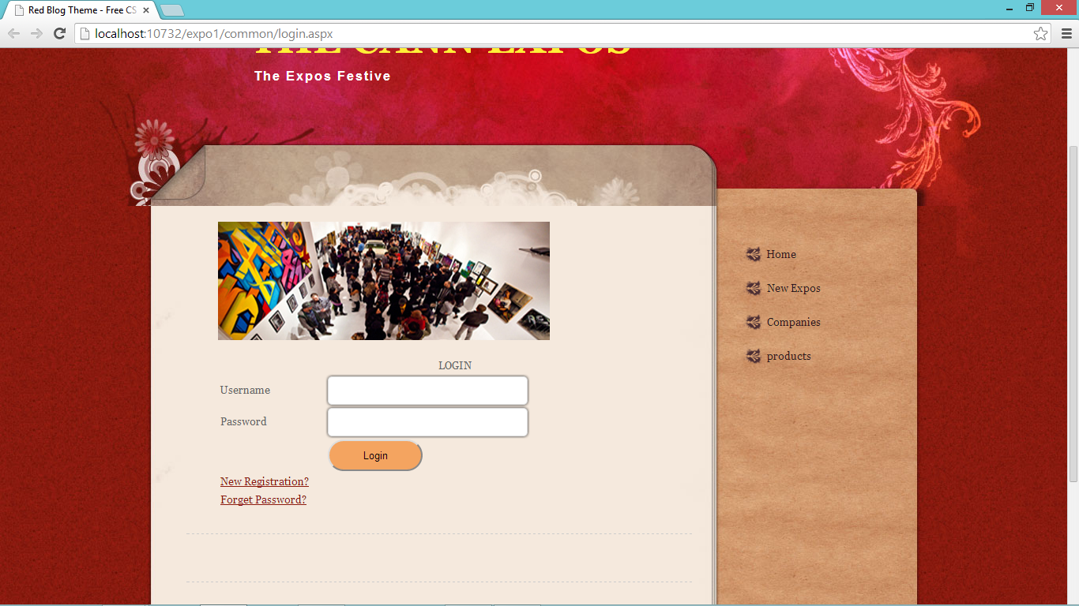

**Forgot password**

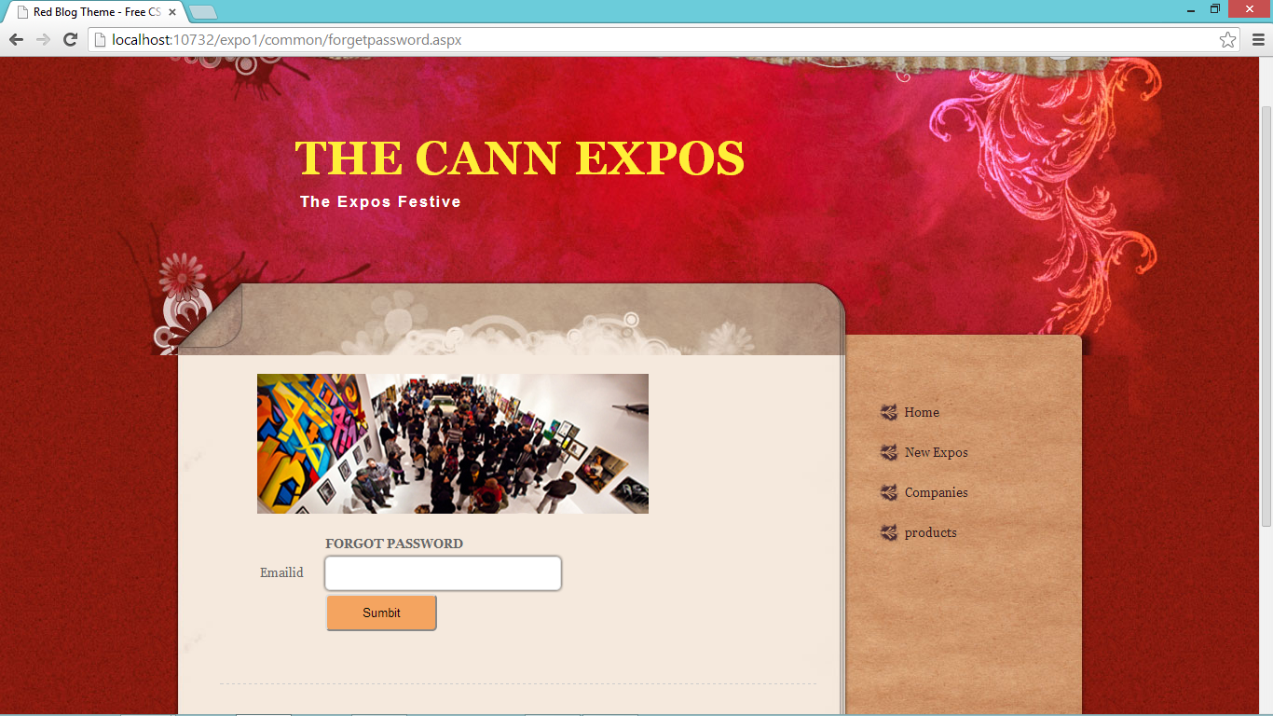

**Exhibitor registration**

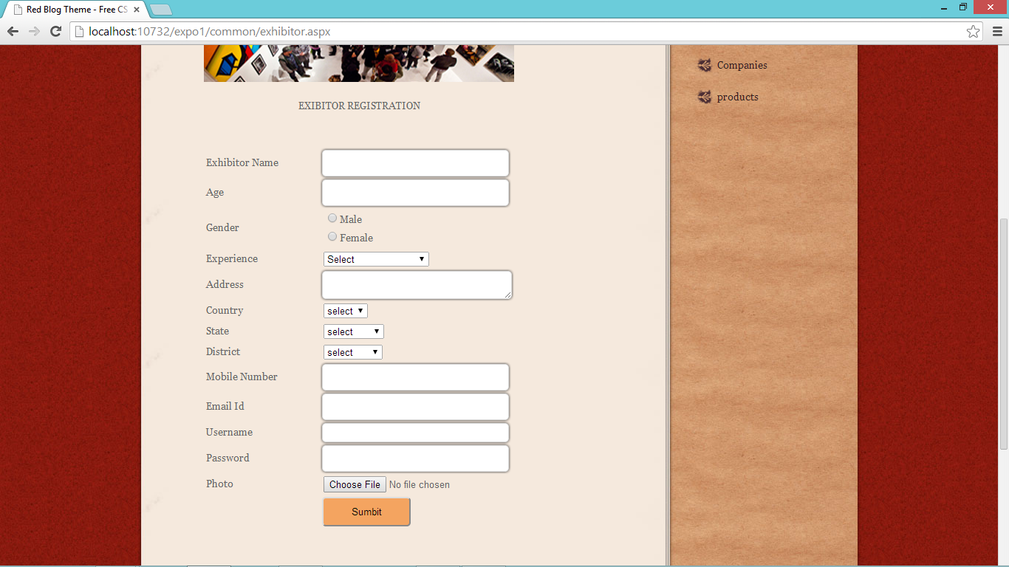

**Company registration**

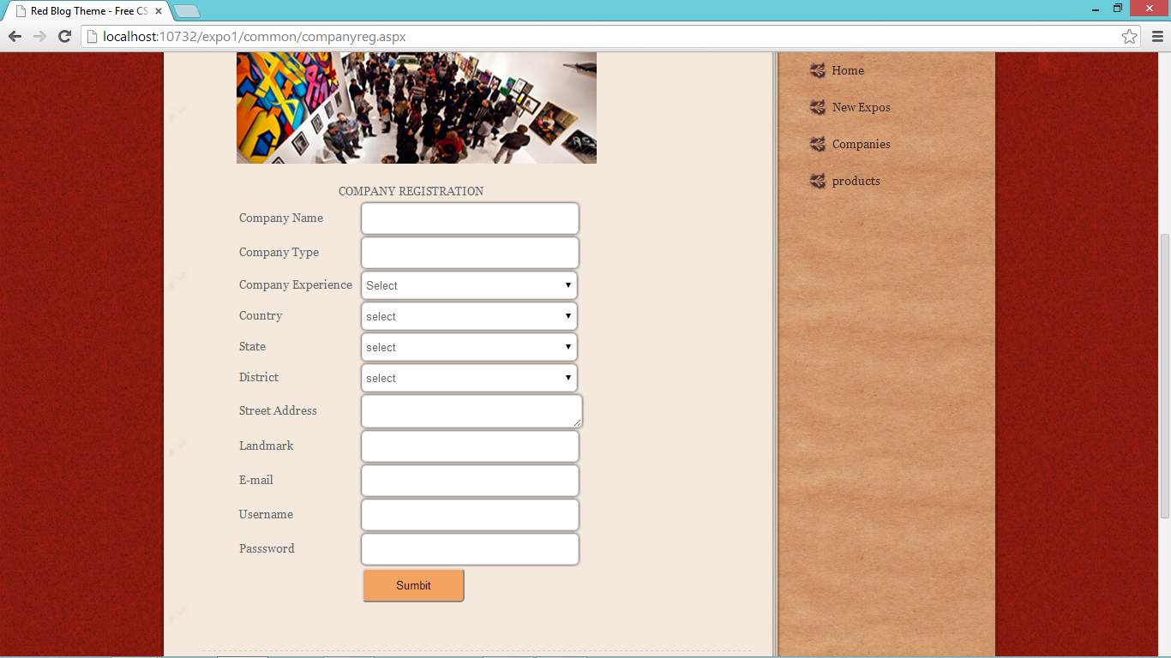

**User registration**

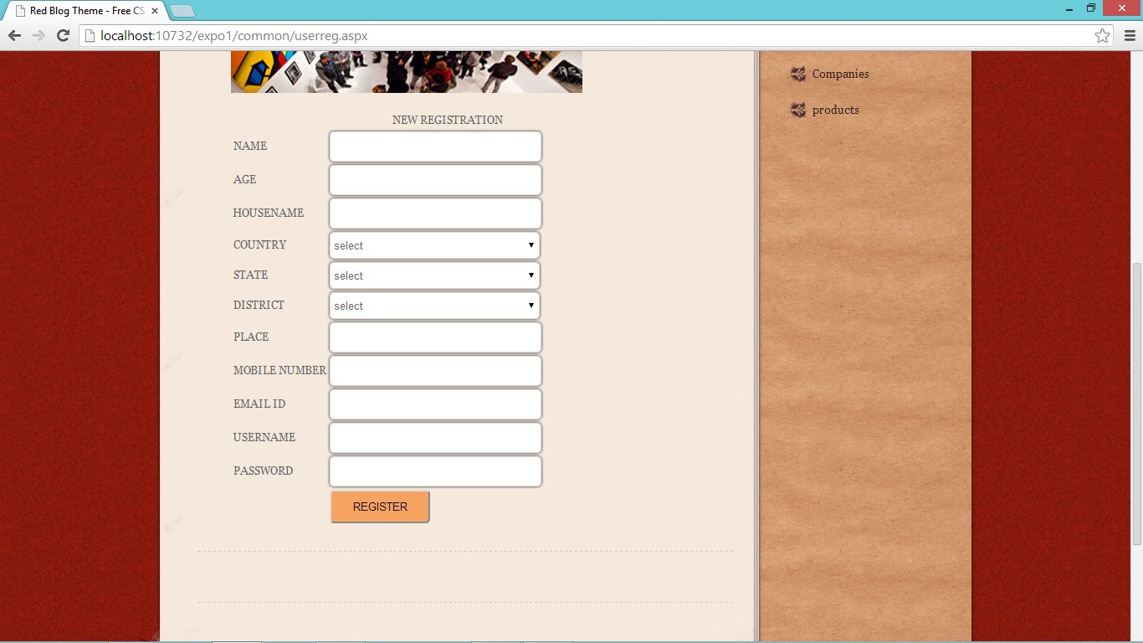

**Admin home**

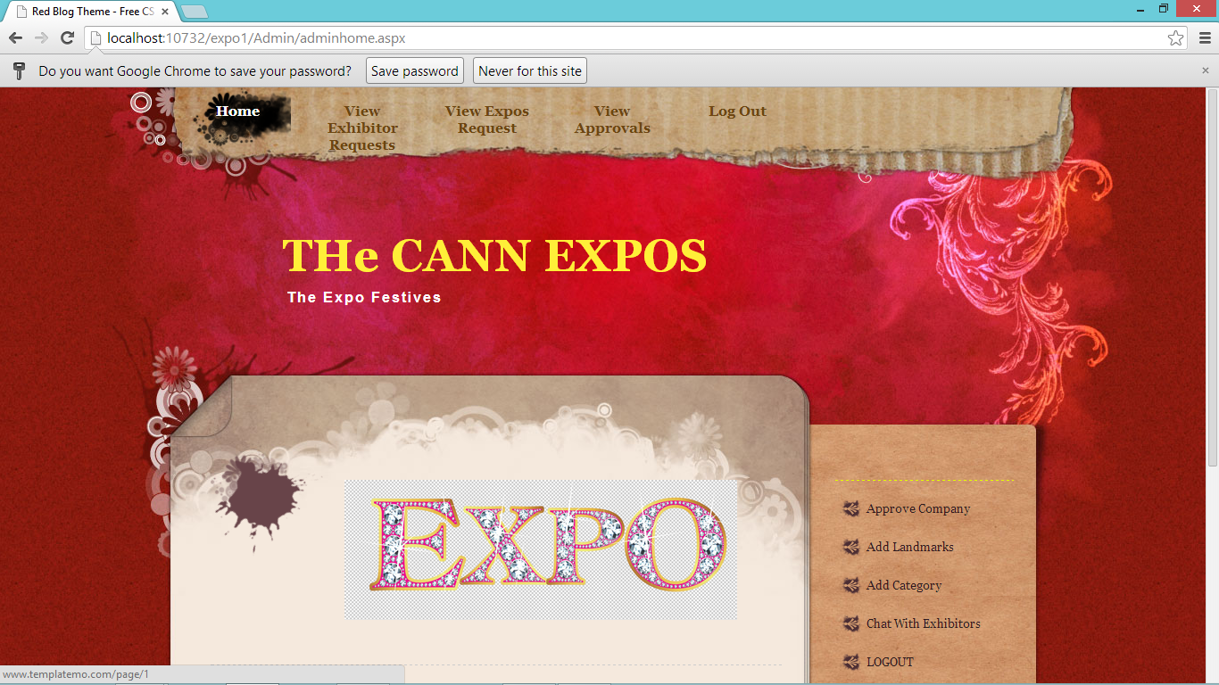

**Exhibitor home**

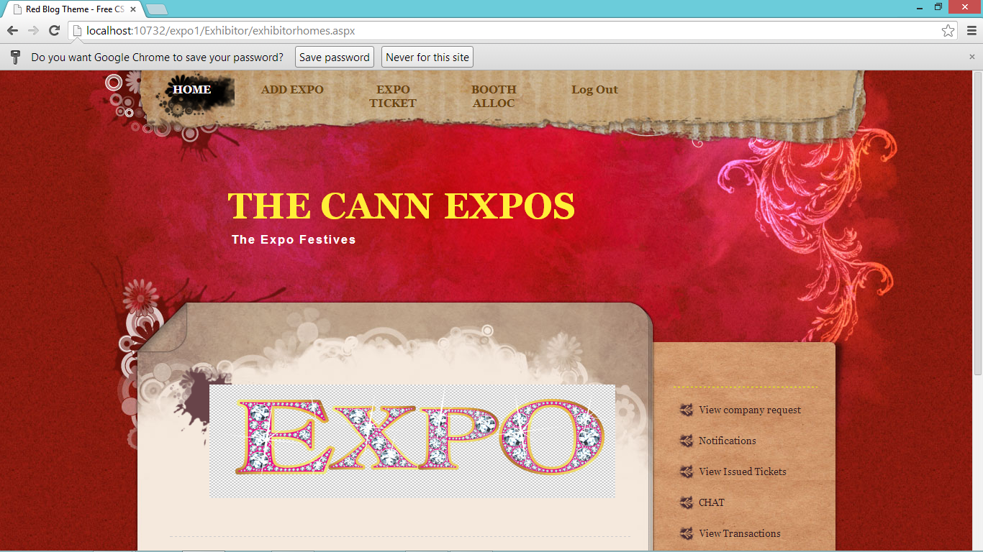

**Company home**

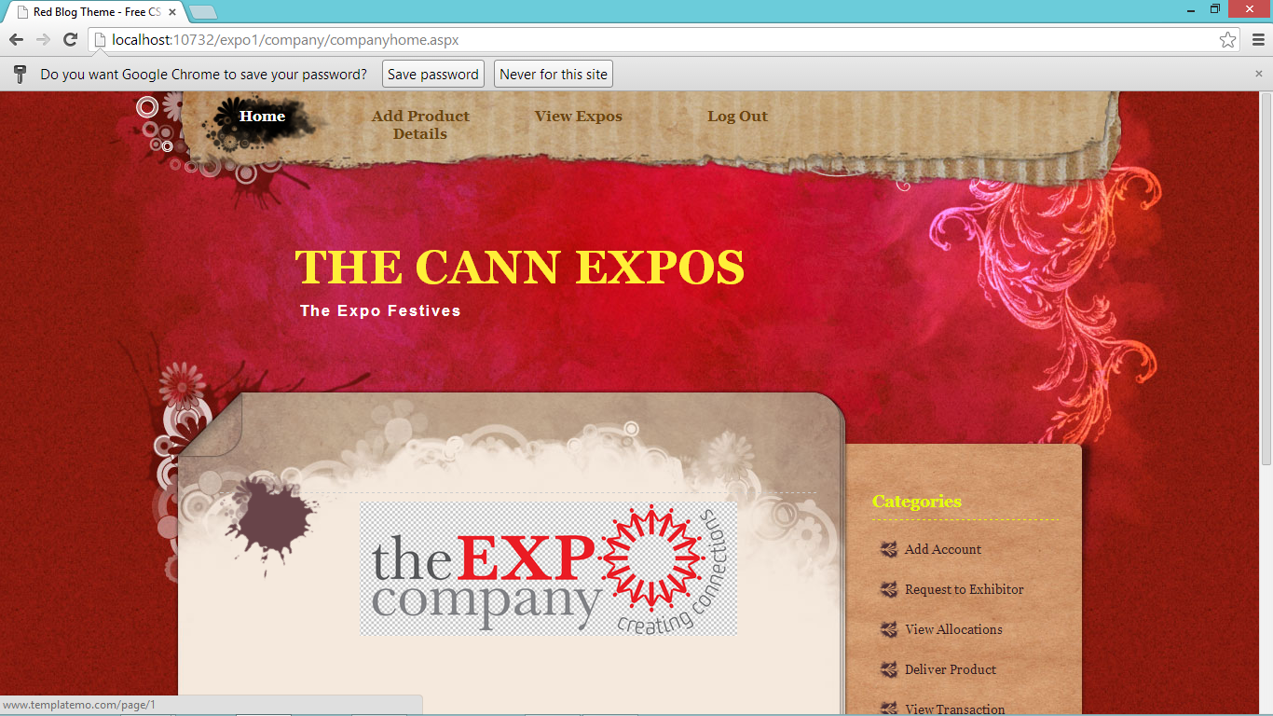

**User home**

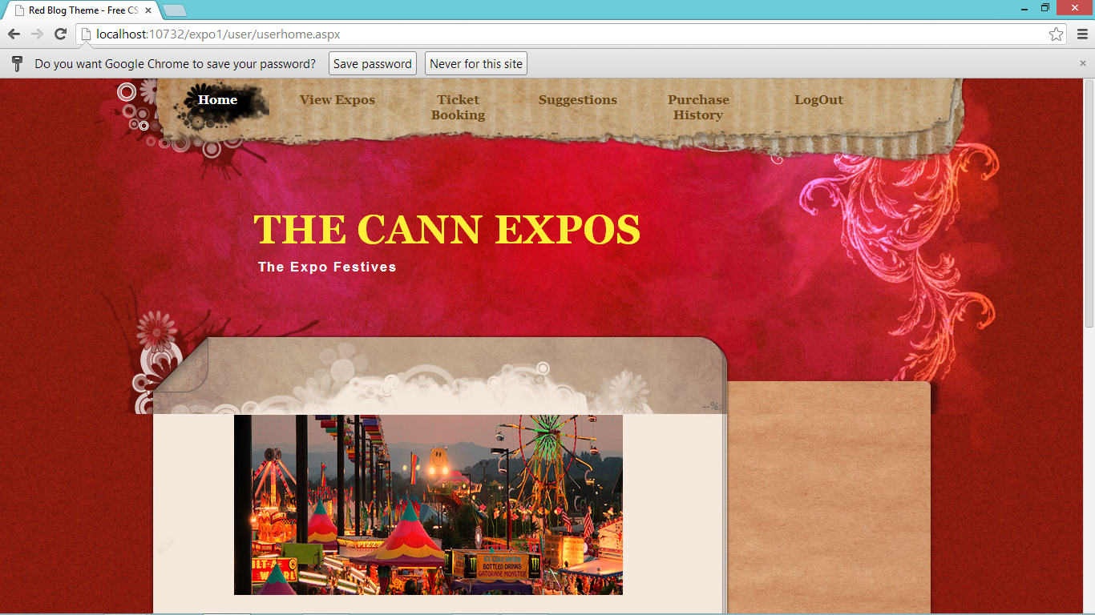

**Exhibitor add expo**

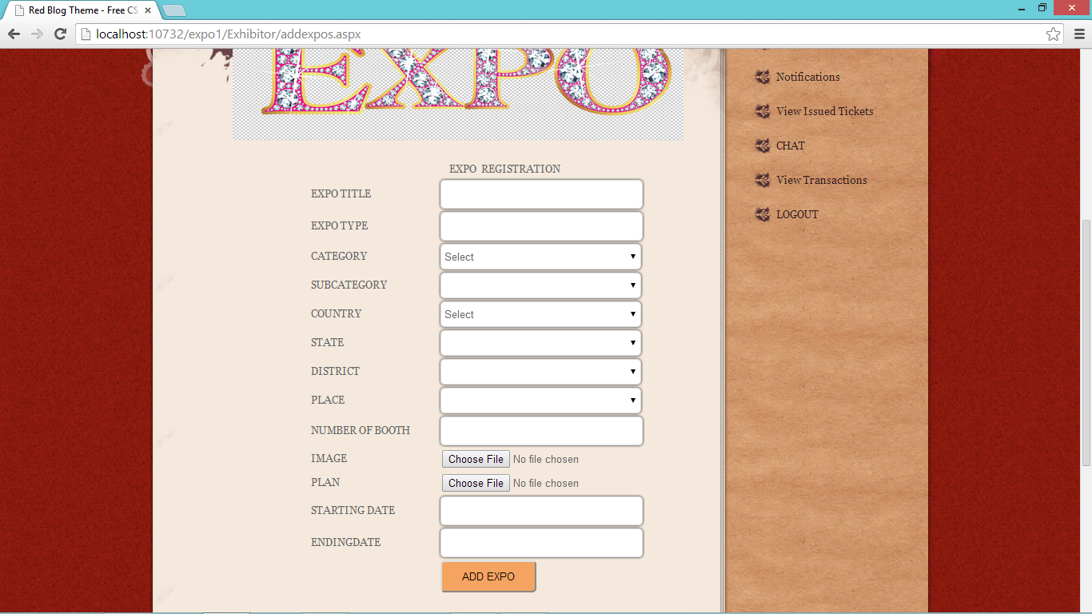

**Company product details**

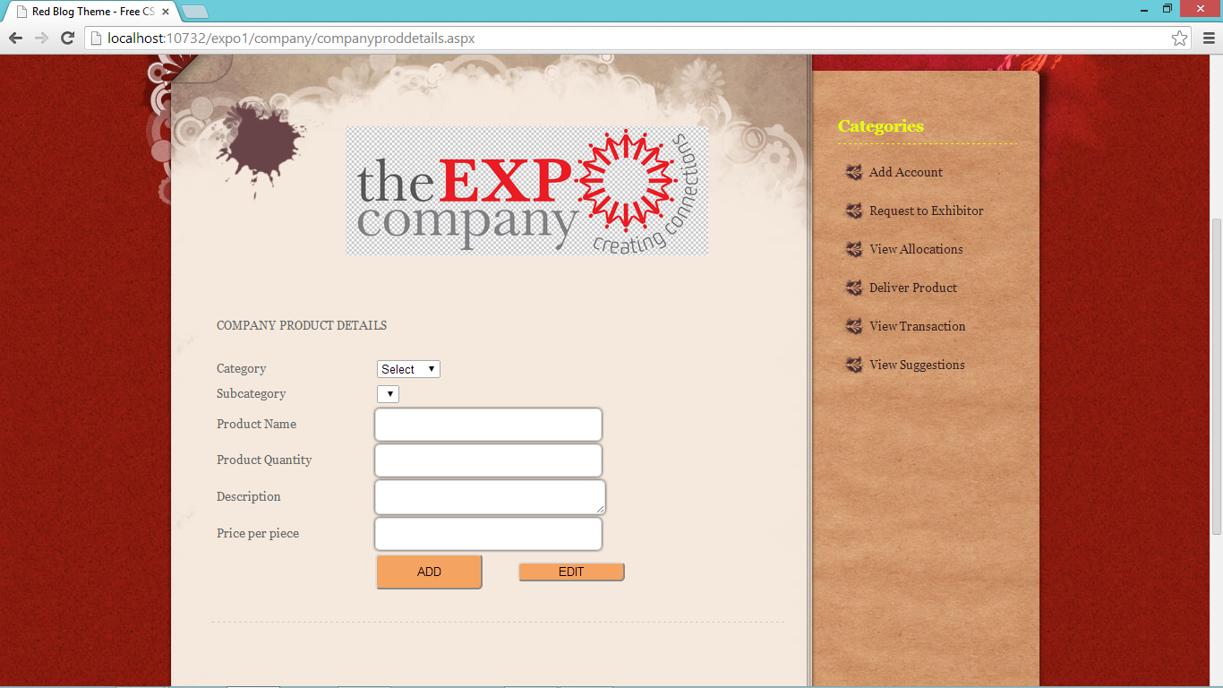

**User ticket book**

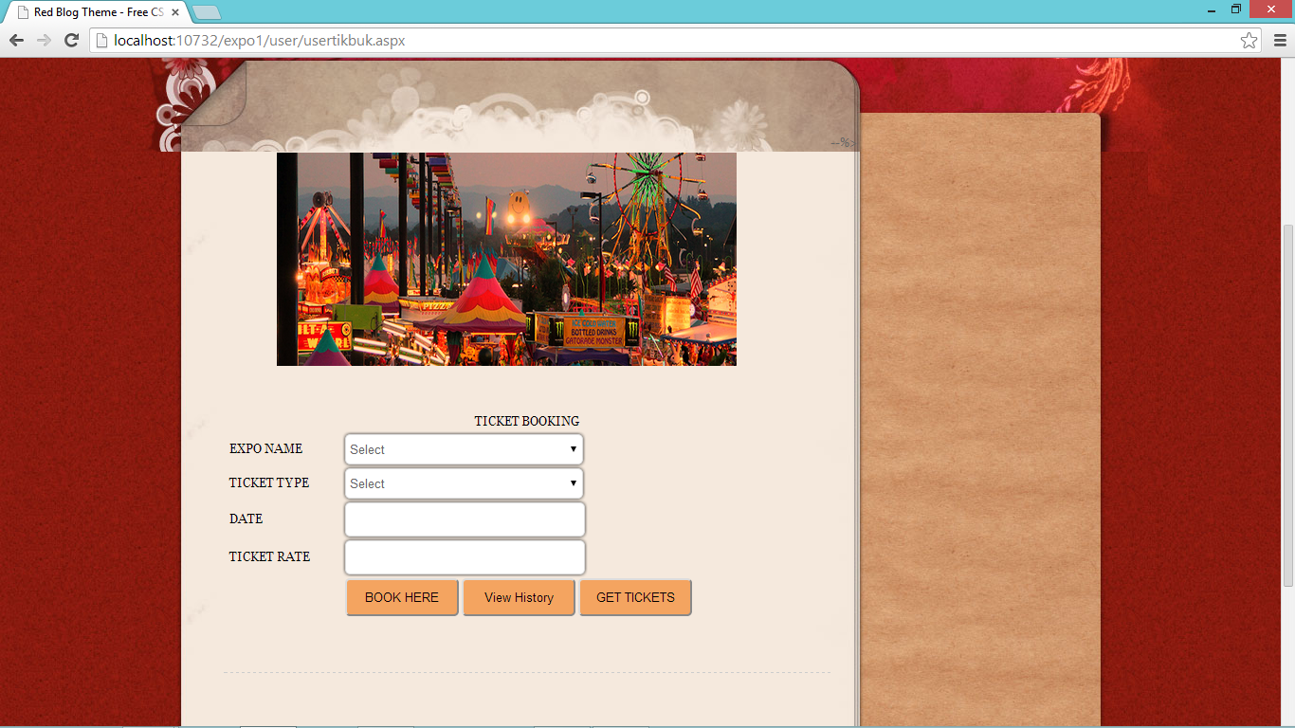

**Chat page**

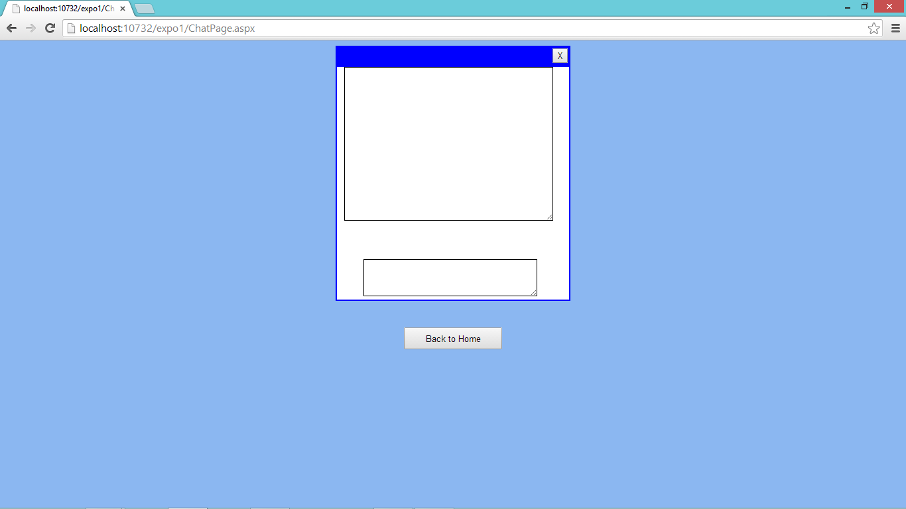

**Transaction page**

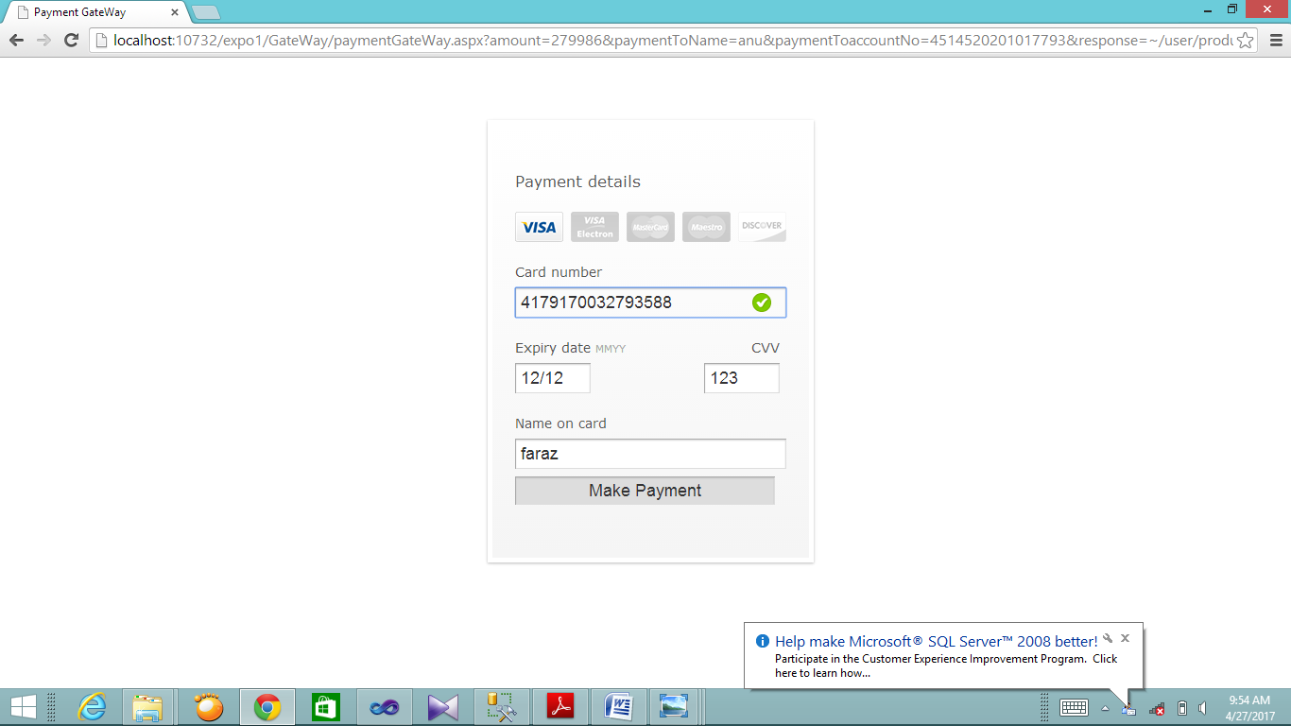

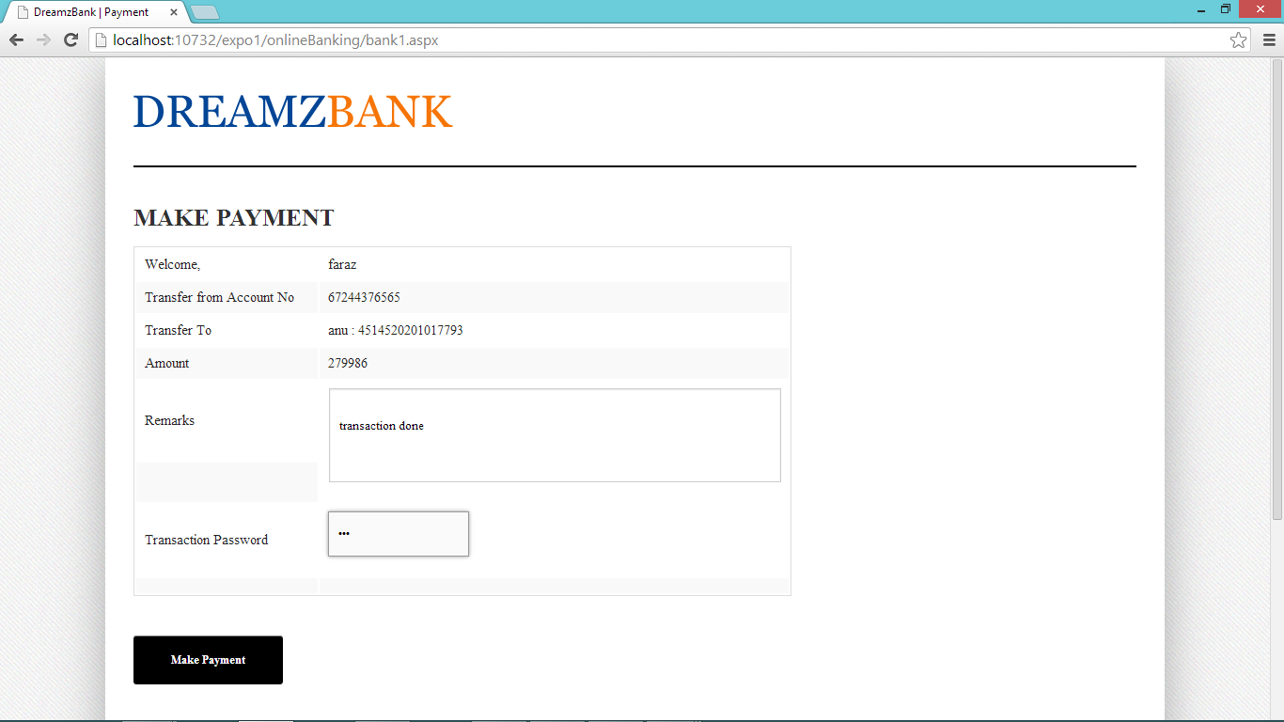

**Code pages**

**Login page**

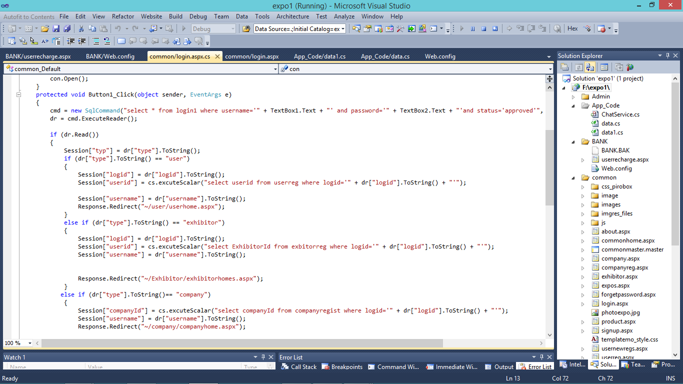

**Forget password**

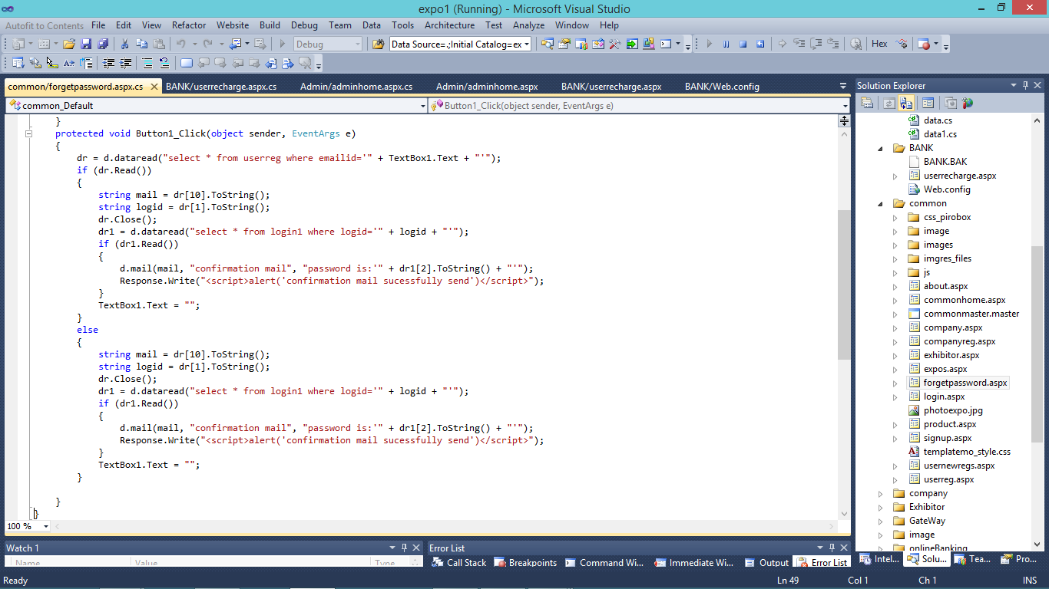

**Exhibitor registration**

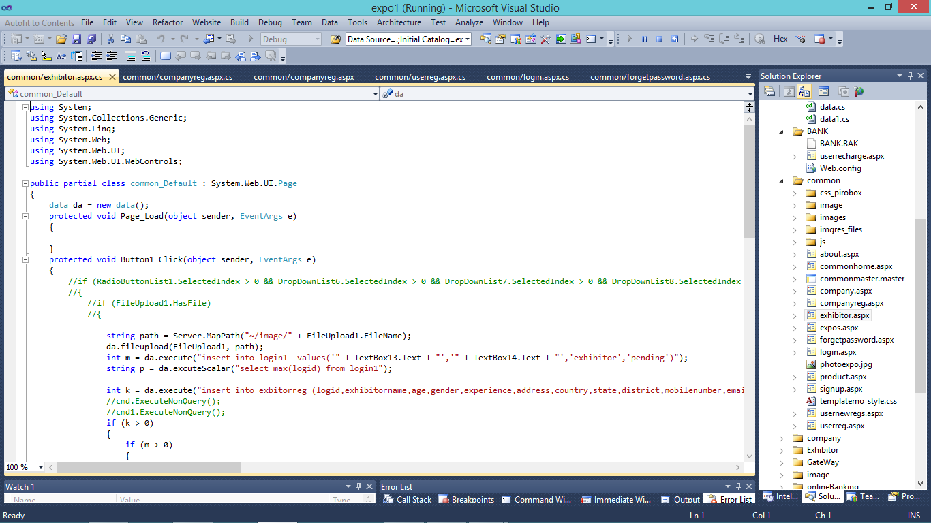

**Company registration**

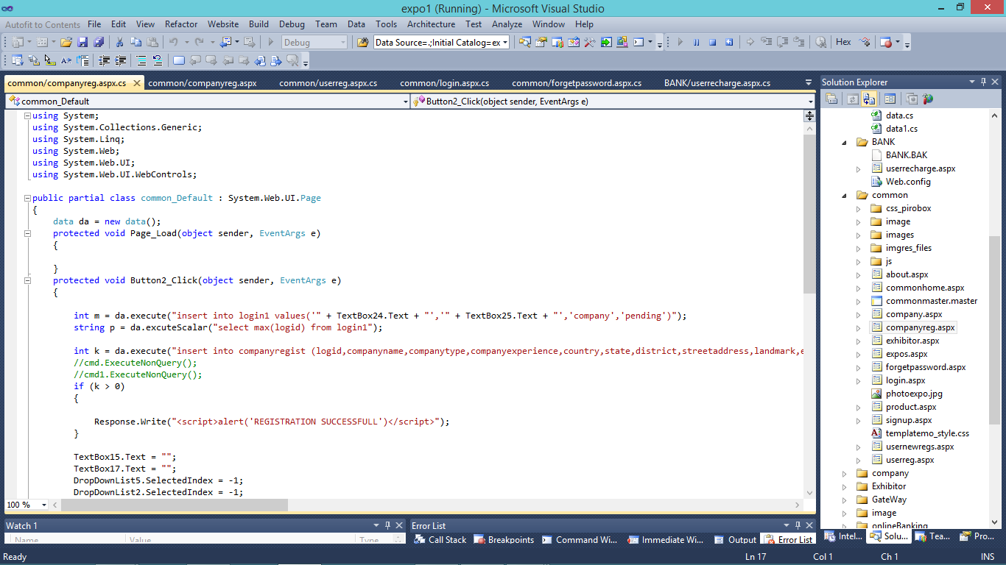

**User registration**

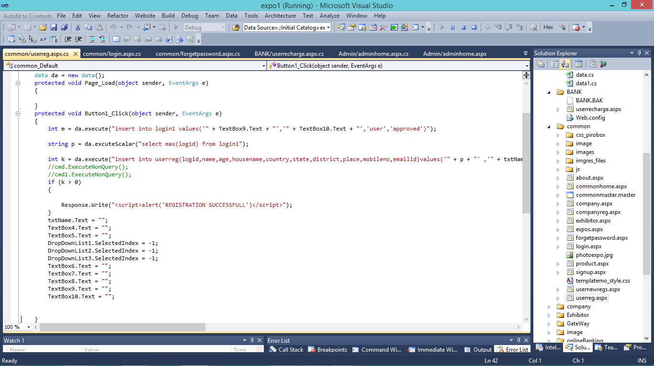

**Admin home**

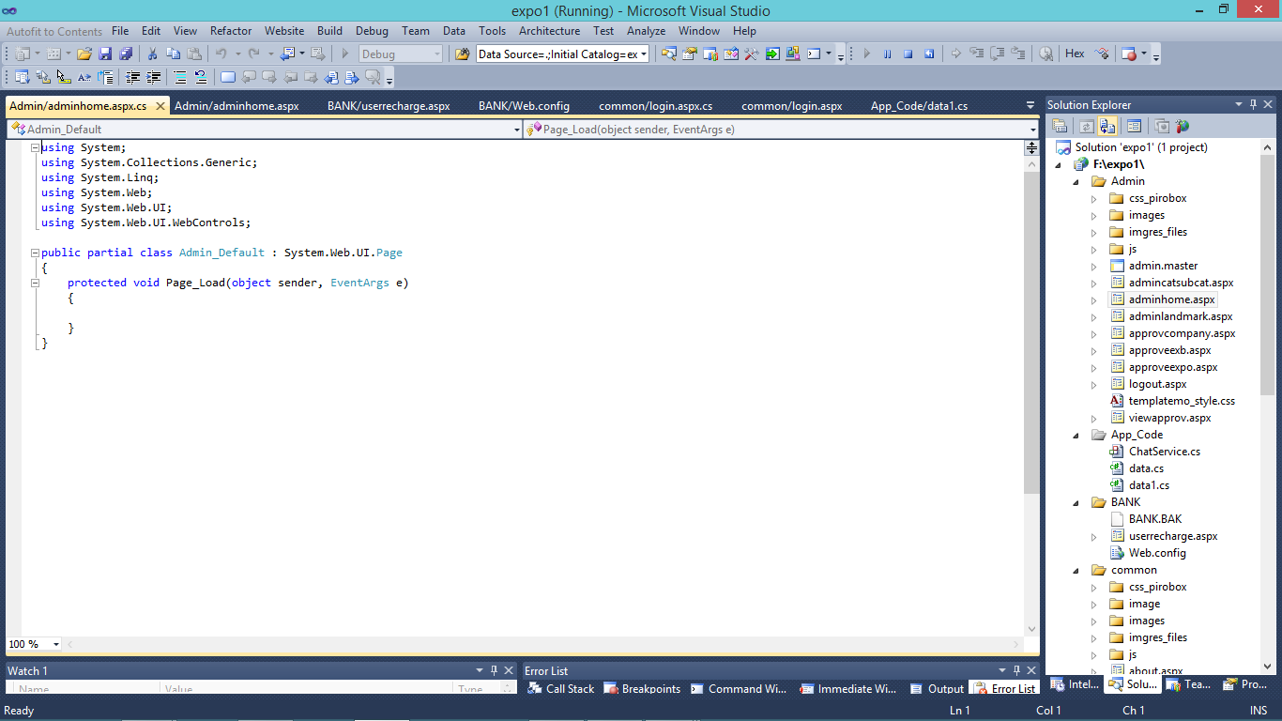

**Exhibitor add expos**

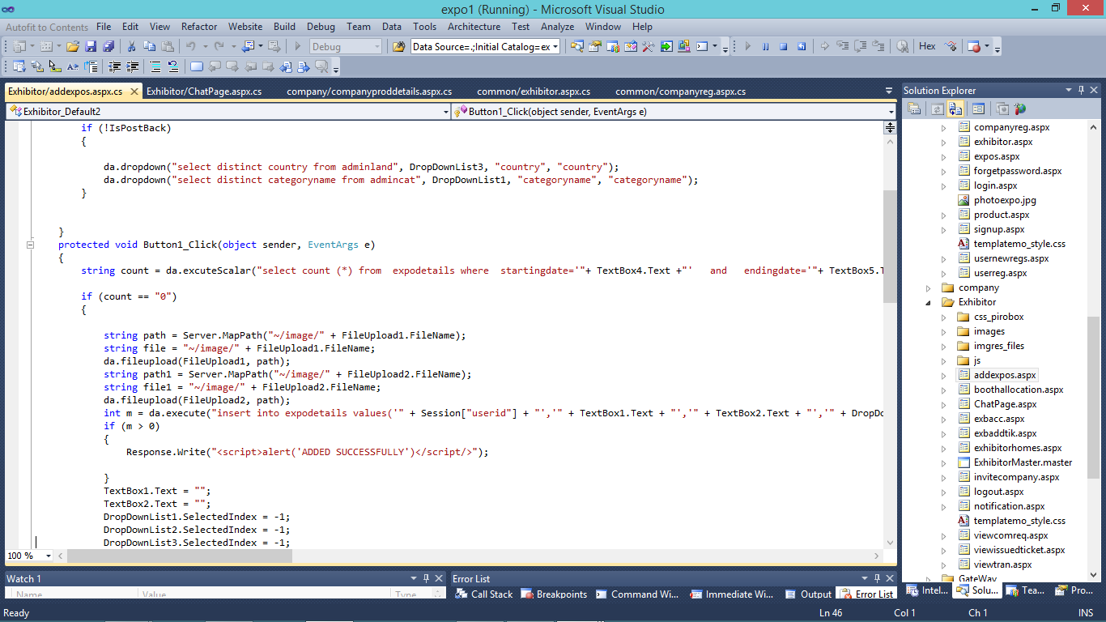

**Company product details**

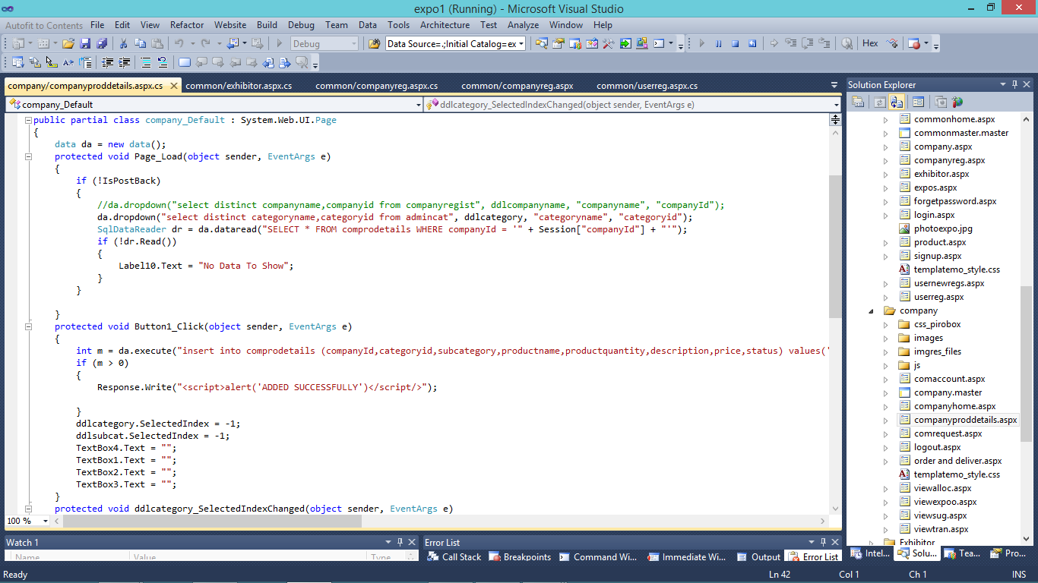

**User ticket booking**

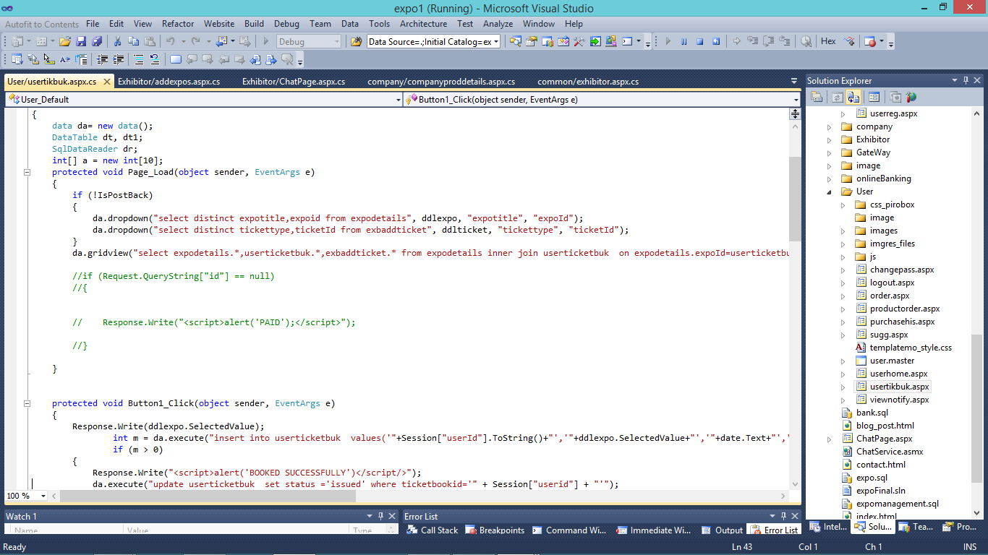

**Chat page**

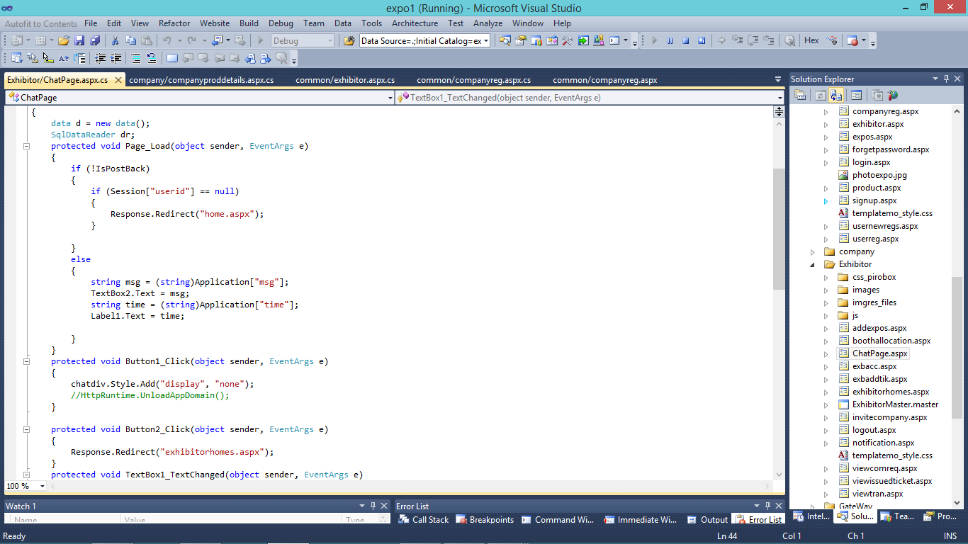

**Transaction**

